BHARATHIDASAN UNIVERSITY

URUMU DHANALAKSHMI COLLEGE

KATTUR, TRICHIRAPALLI-620019

NAAN MUDHALVAN SCHEME

PG & RESEARCH DEPARTMENT OF PHYSICS

TITLE: PLUGGING INTO THE FUTURE: AN EXPLORATION OF ELECTRICITY CONSUMTION PATTERNS

TEAM MEMBER:

1.S.SAPARINATHAN

2.R.RAGHUL

3.C.SAKTHI

4.G.PUGAZHENTHI

INTRODUCTION

**India is the world's third-largest producer and third-largest consumer of electricity. The national electric grid in India has an installed capacity of 370.106 GW as of 31 March 2020. Renewable power plants, which also include large hydroelectric plants, constitute 35.86% of India's total installed capacity. During the fiscal year (FY) 2019–20, the total electricity generation in the country was 1,598 TWh, of which 1,383.5 TWh generated by utilities. The gross electricity consumption per capita in FY2019 was 1,208 kWh.**

**In 2015-16, electric energy consumption in agriculture was recorded as being the highest (17.89%) worldwide. The per capita electricity consumption is low compared to most other countries despite India having a low electricity tariff.**

**In light of the recent COVID-19 situation, when everyone has been under lockdown for the months of March to June the impacts of the lockdown on economic activities have been faced by every sector in a positive or a negative way.**

**The dataset is exhaustive in its demonstration of energy consumption state wise.**

**Analysing Electricity Consumption in India from Jan 2019 till 5th December 2020. This dataset contains a record of Electricity consumption in each states of India, here we are going to analyse State wise , Region wise and Overall Electricity consumption in India.**

**Technical Architecture:**

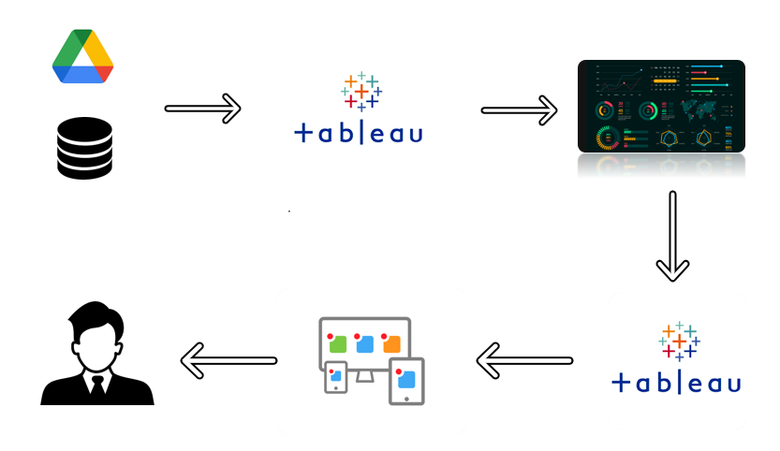

**Project Flow**

To accomplish this, we have to complete all the activities listed below,

* Define Problem / Problem Understanding
  + Specify the business problem
  + Business requirements
  + Literature Survey
  + Social or Business Impact.
* Data Collection & Extraction from Database
  + Collect the dataset,
  + Storing Data in DB
  + Perform SQL Operations
  + Connect DB with Tableau
* Data Preparation
* Prepare the Data for Visualization
* Data Visualizations
  + No of Unique Visualizations
* Dashboard
  + Responsive and Design of Dashboard
* Story
  + No of Scenes of Story
* Performance Testing
  + Amount of Data Rendered to DB ‘
  + Utilization of Data Filters
  + No of Calculation Fields
  + No of Visualizations/ Graphs
* Web Integration
  + Dashboard and Story embed with UI With Flask
* Project Demonstration & Documentation
  + Record explanation Video for project end to end solution
  + Project Documentation-Step by step project development procedure

**PURPOSE:**

Electricity is at the heart of modern economies and it is providing a rising share of energy services. Demand for electricity is set to increase further as a result of rising household incomes, with the electrification of transport and heat, and growing demand for digital connected devices and air conditioning.

Rising electricity demand was one of the key reasons why global CO2 emissions from the power sector reached a record high in 2018, yet the commercial availability of a diverse suite of low emissions generation technologies also puts electricity at the vanguard of efforts to combat climate change and pollution. Decarbonised electricity, in addition, could provide a platform for reducing CO2 emissions in other sectors through electricity-based fuels such as hydrogen or synthetic liquid fuels. Renewable energy also has a major role to play in providing access to electricity for all.

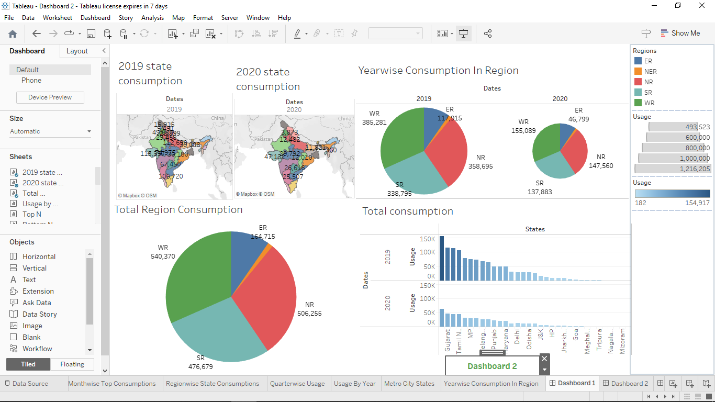

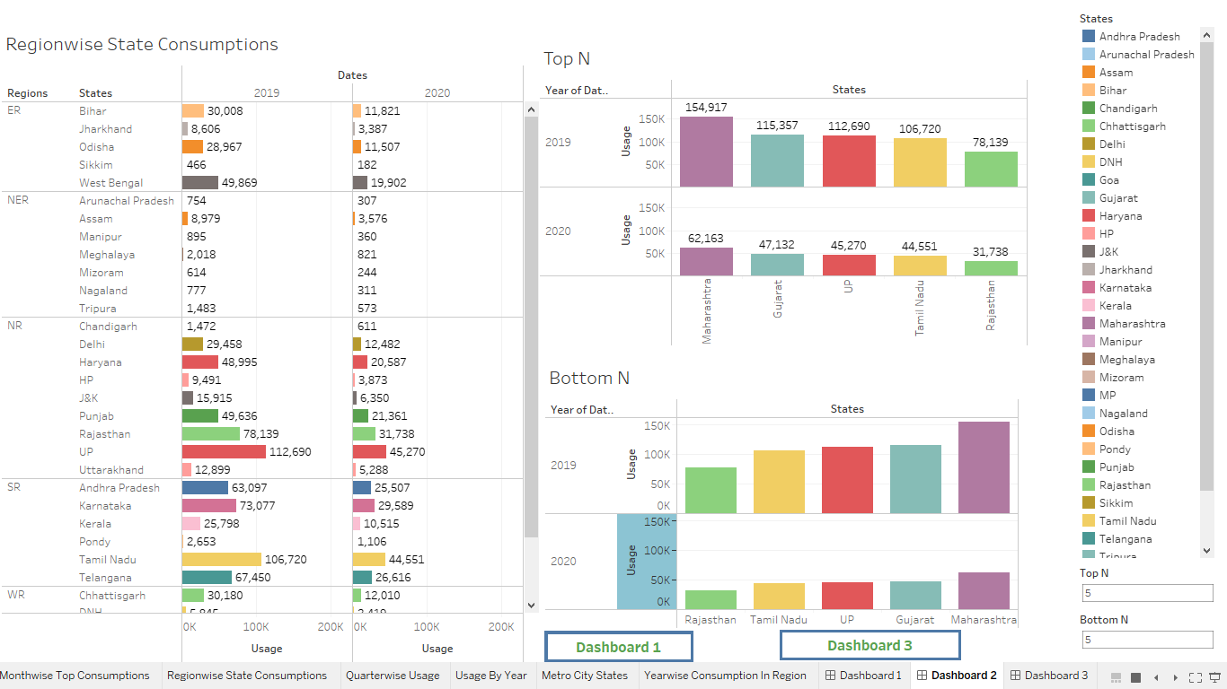

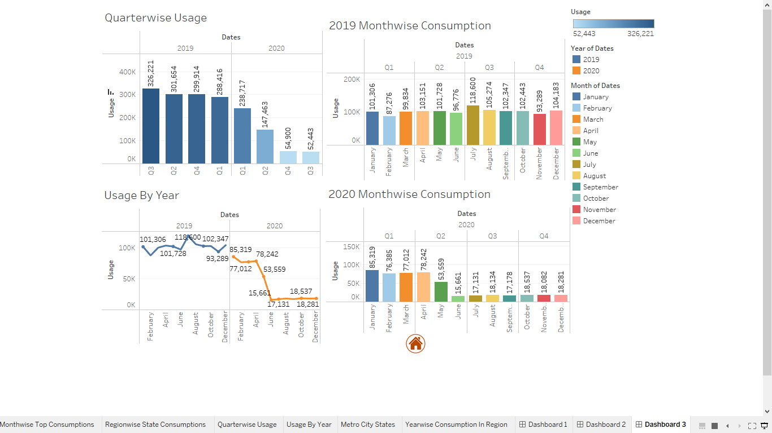

ADVANTAGE:

In the **Stated Policies Scenario**, global electricity demand grows at 2.1% per year to 2040, twice the rate of primary energy demand. This raises electricity’s share in total final energy consumption from 19% in 2018 to 24% in 2040. Electricity demand growth is set to be particularly strong in developing economies. Government policies, market conditions and available technologies collectively set a course for electricity supply to shift towards low-carbon sources, with their share increasing from 36% today to 52% in 2040 in the Stated Policies Scenario.

In the **Sustainable Development Scenario** electricity plays an even larger role, reaching 31% of final energy consumption. In the Sustainable Development Scenario, electricity is one of the few energy sources that sees growing consumption in 2040 – mainly due to electric vehicles – alongside the direct use of renewables, and hydrogen. The share of electricity in final consumption, less than half that of oil today, overtakes oil by 2040. Accelerated efforts on renewables, nuclear power and carbon capture technologies rapidly decarbonise electricity supply, compensating for the sharp decline of coal-fired power generation and reducing power sector CO2 emissions by three-quarters by 2040.

**Highlights**

DISADVANTAGE:

Electricity demand follows two distinct regional paths. In advanced economies, future growth linked to increasing digitalisation and electrification is largely offset by energy efficiency improvements. In developing economies, rising incomes, expanding industrial output and a growing services sector push demand firmly up. Developing economies contribute nearly 90% of global electricity demand growth to 2040 in the Stated Policies Scenario, but demand per person in these economies remains 60% lower than in advanced economies.

STORY:

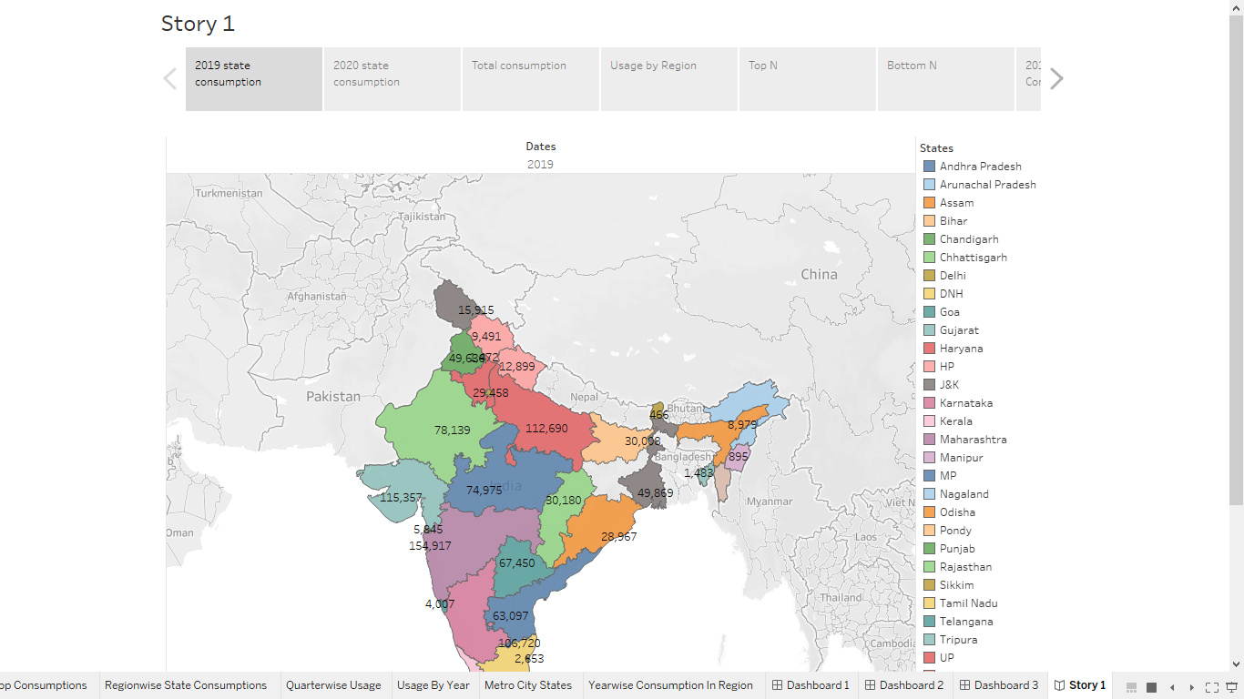

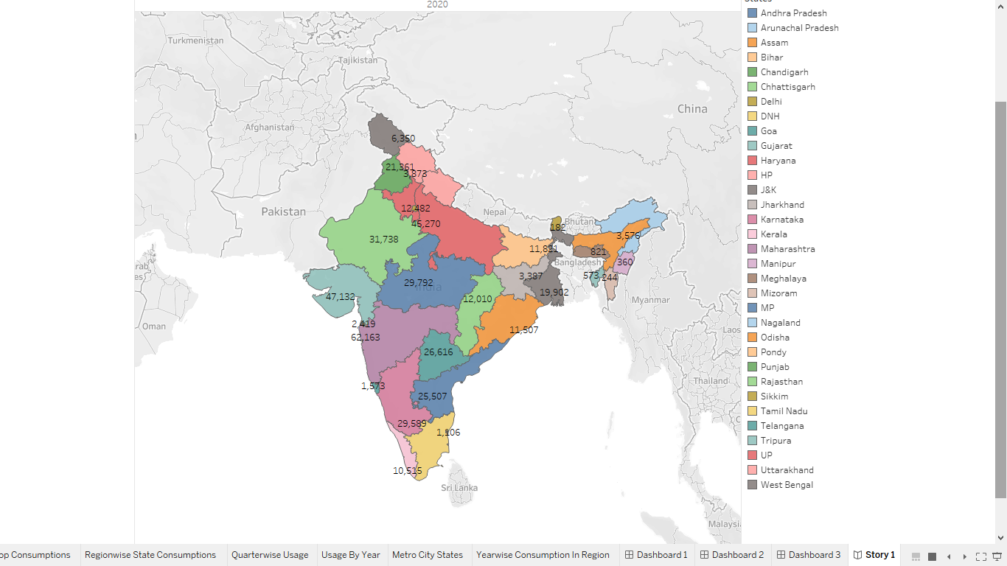

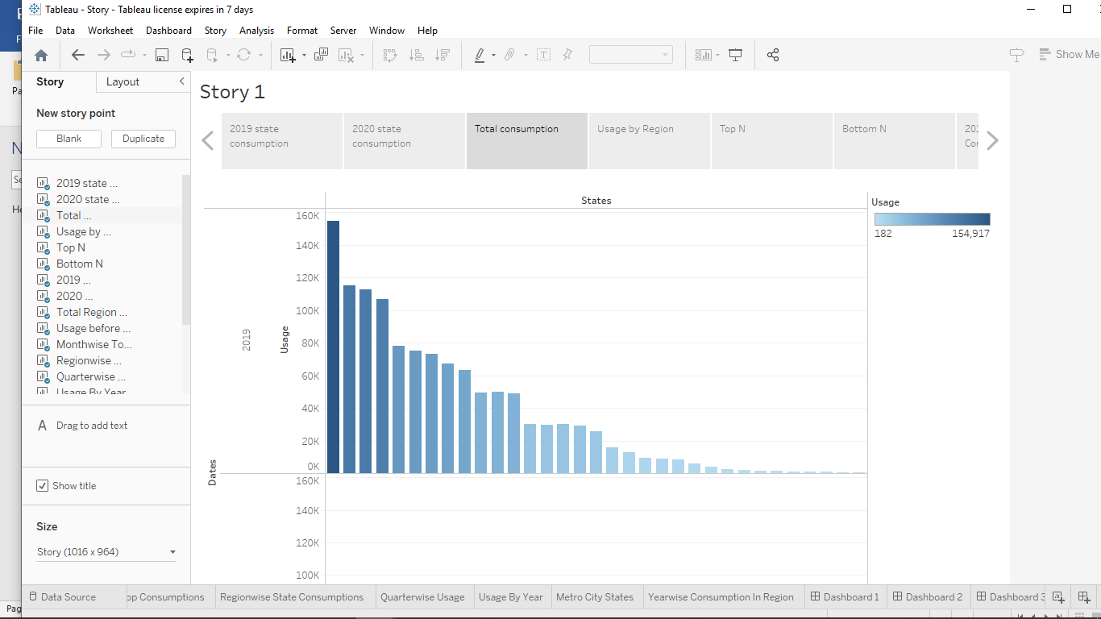

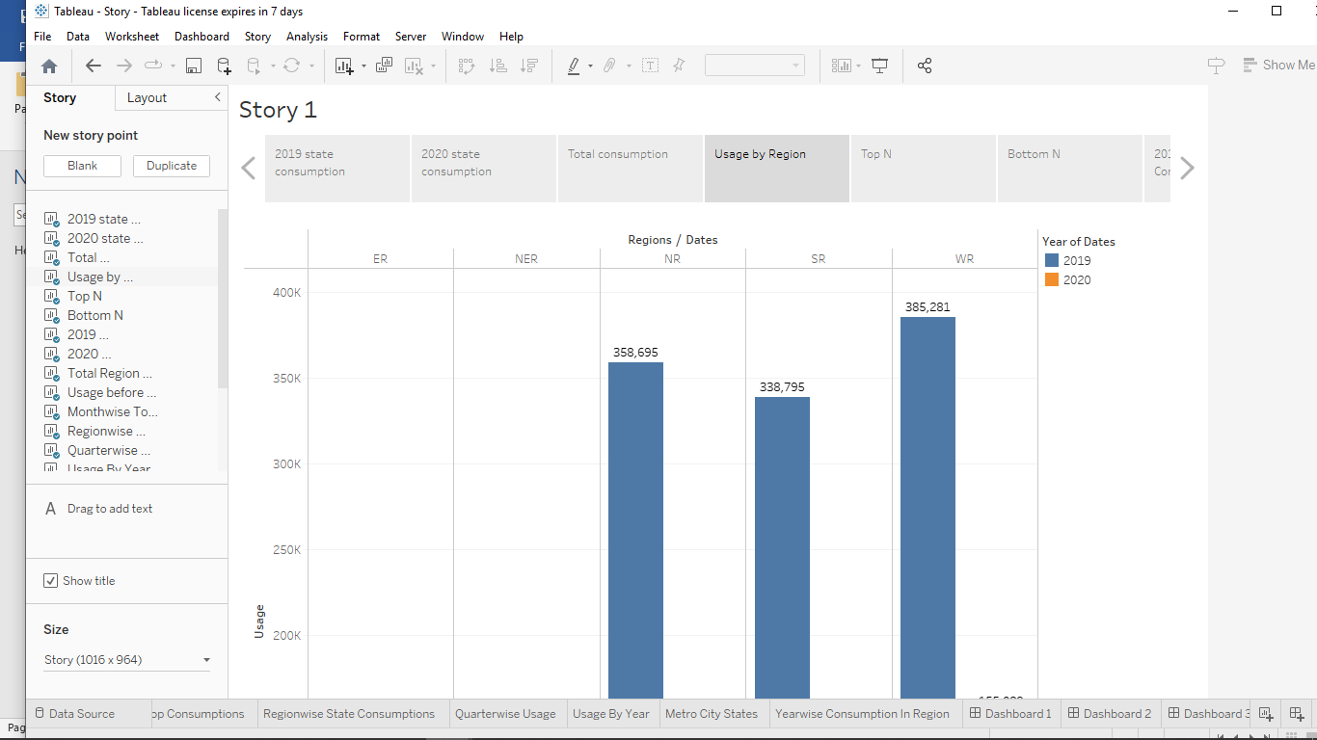

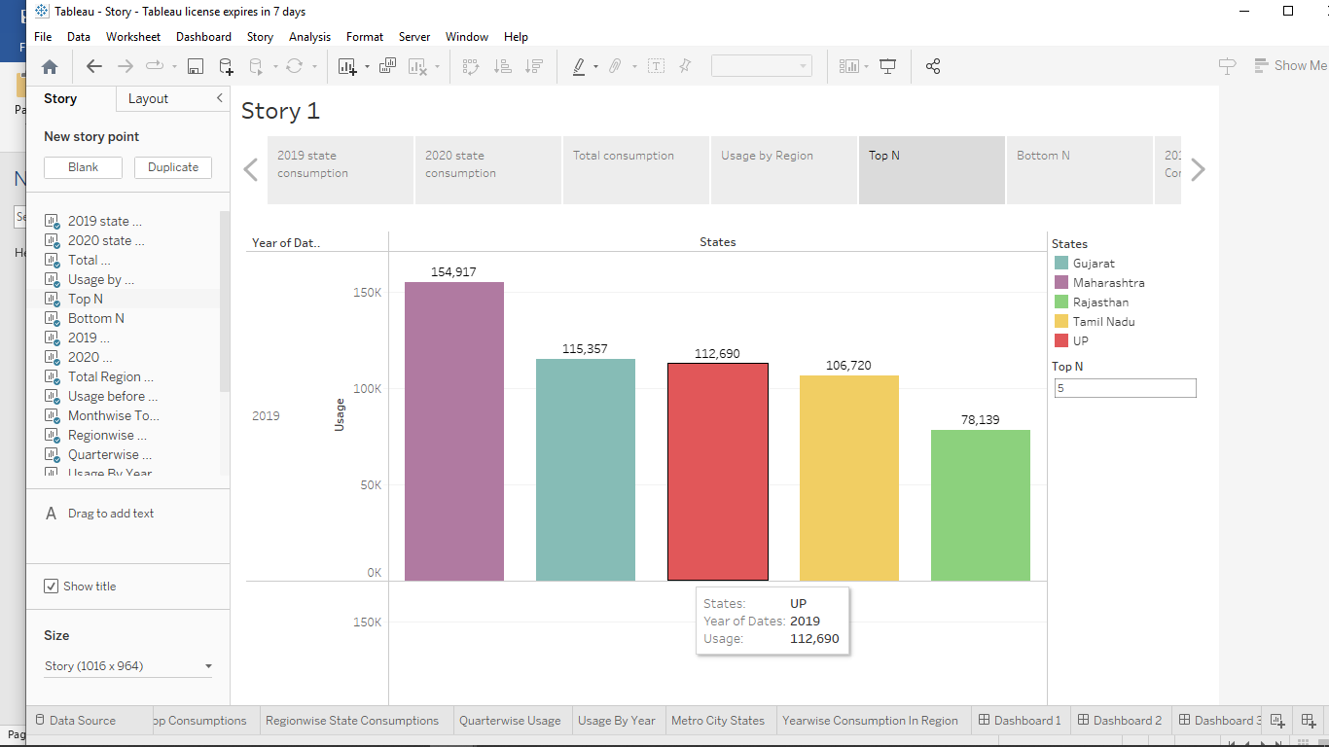

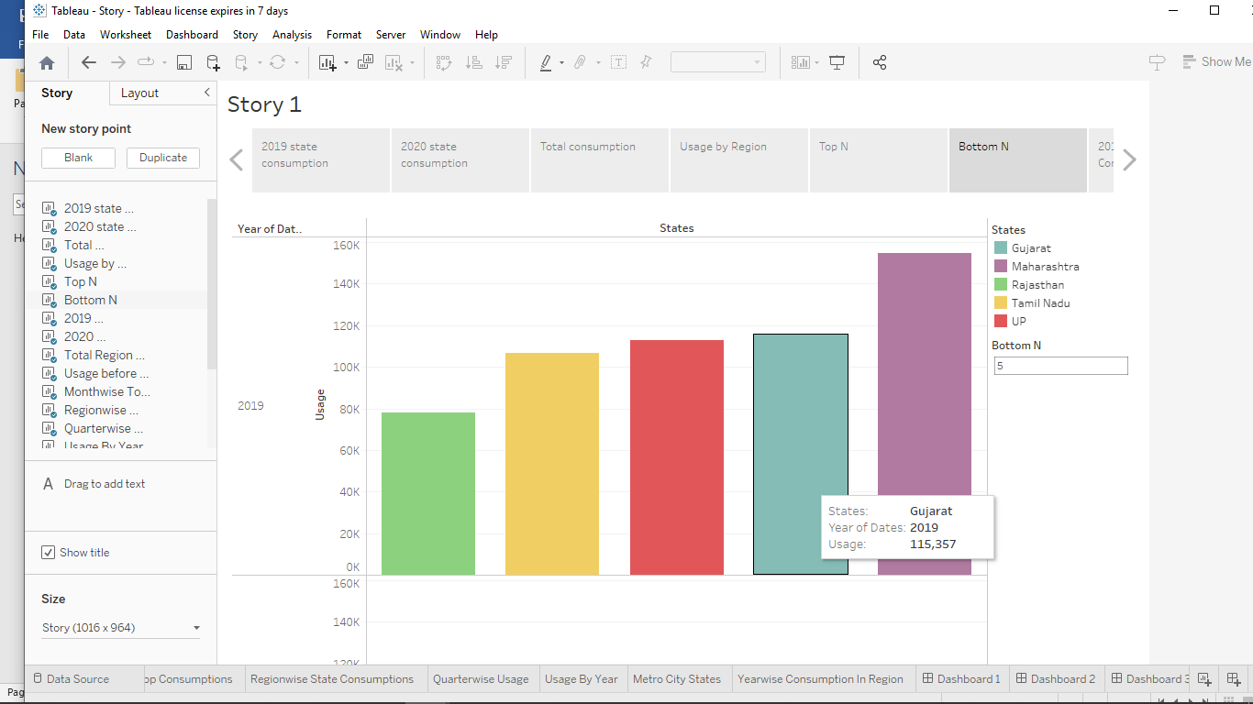

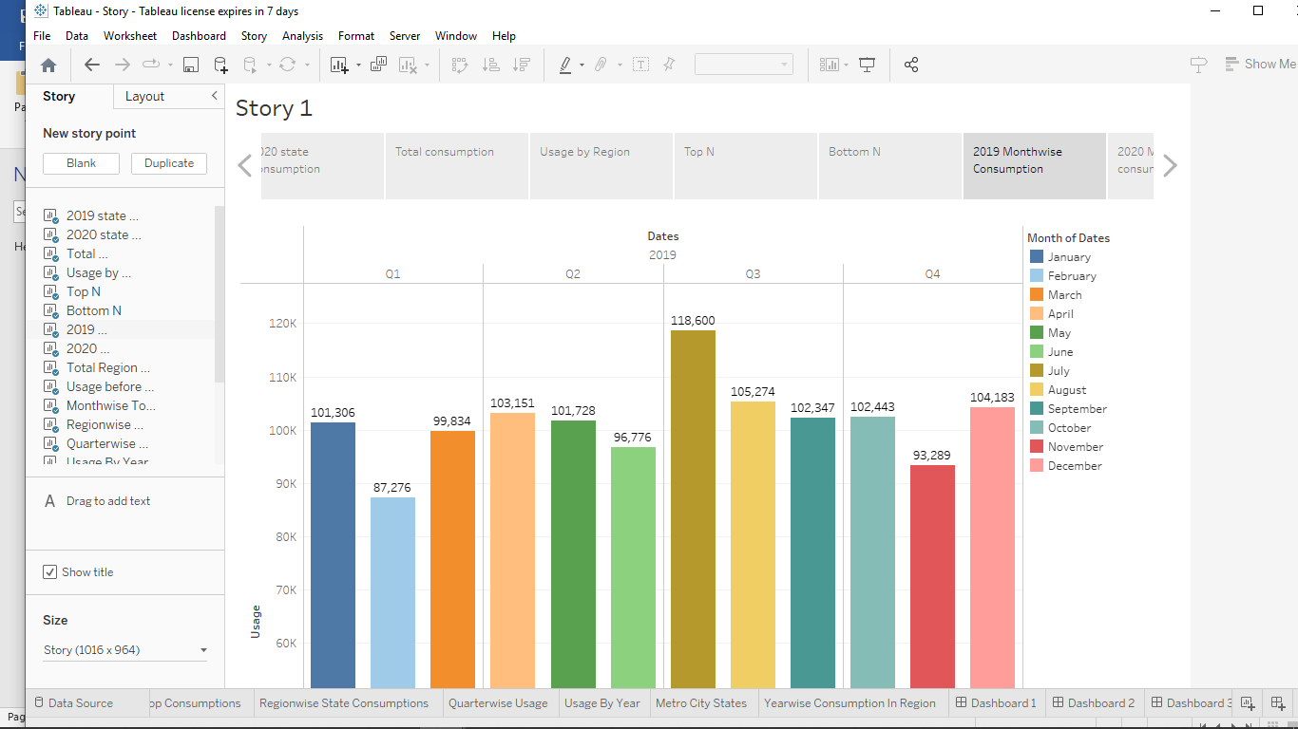 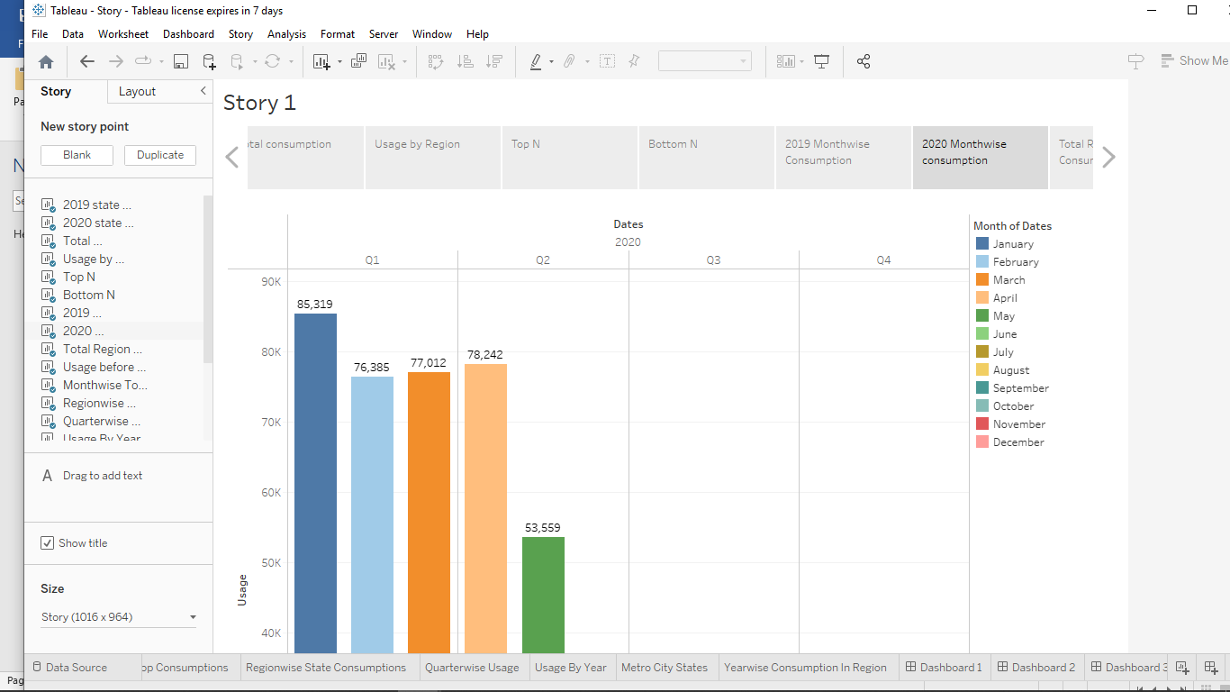

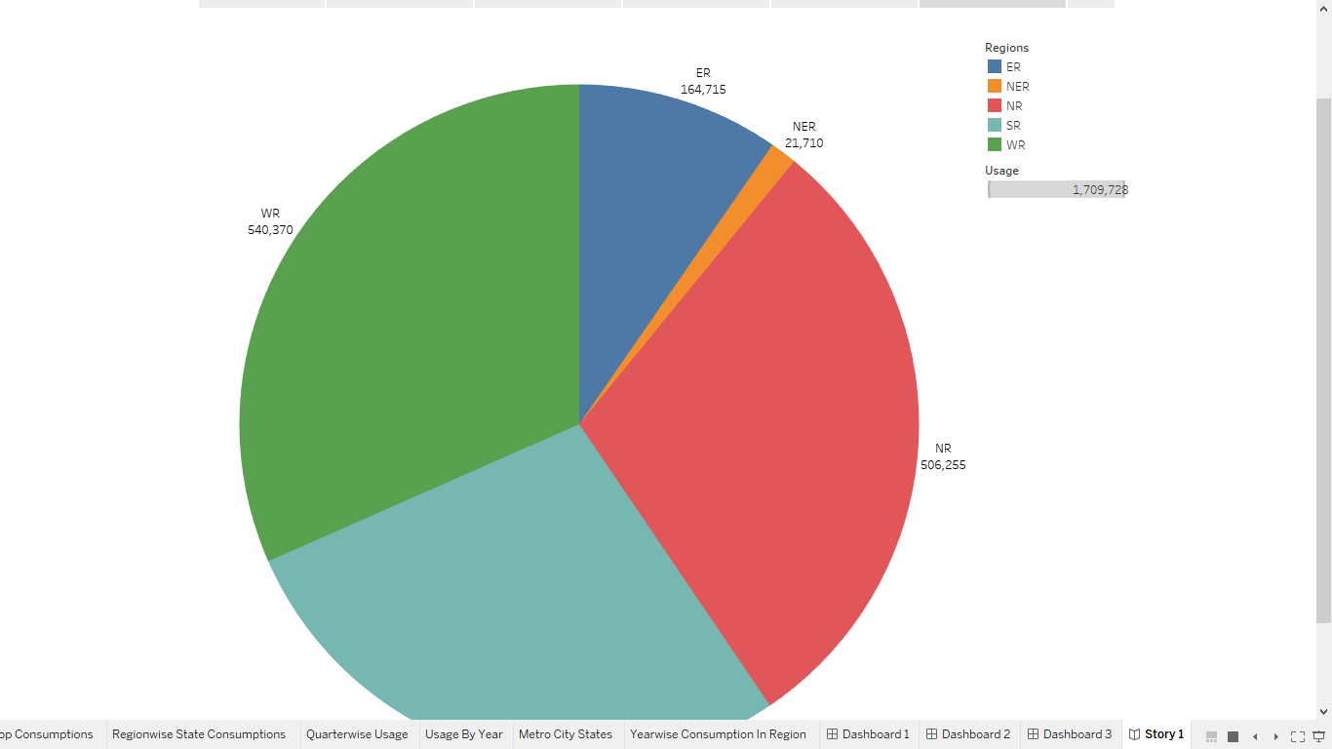

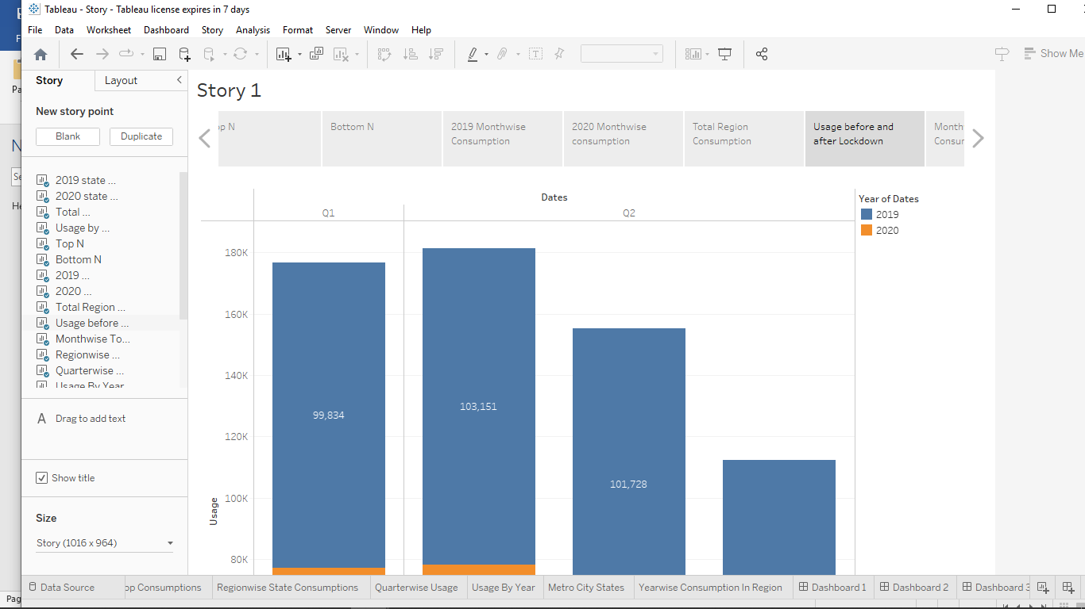

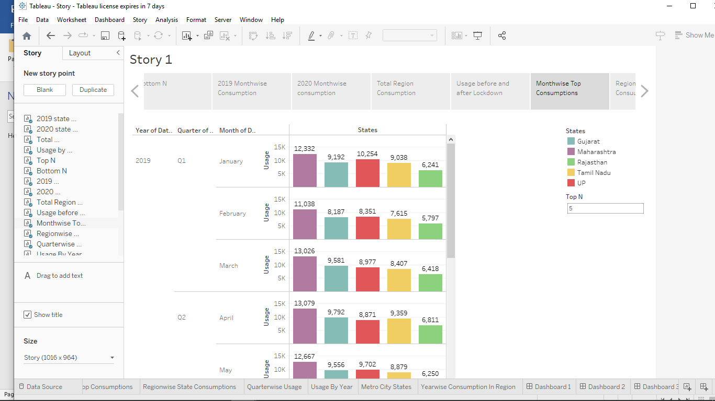

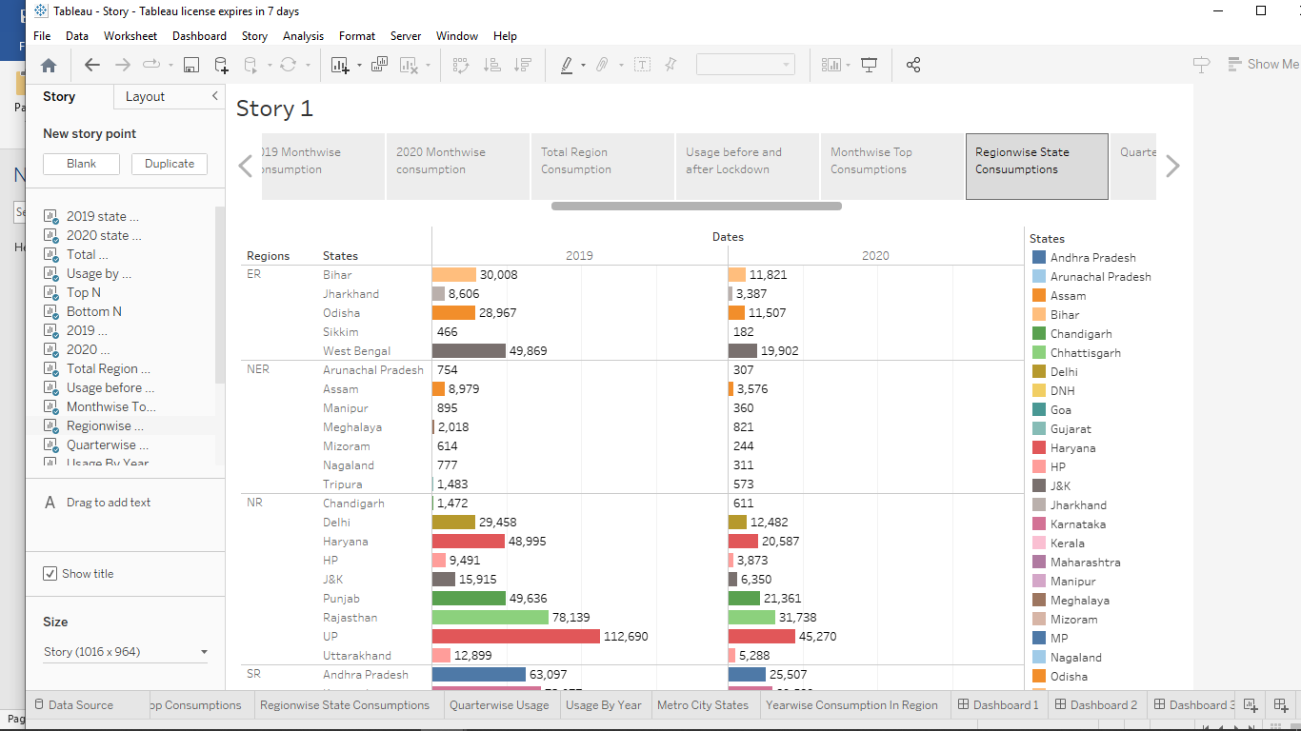

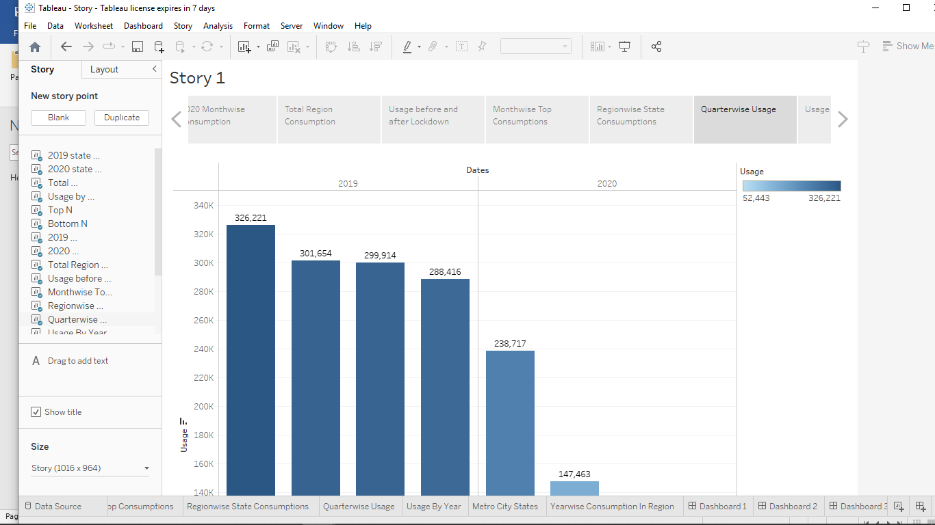

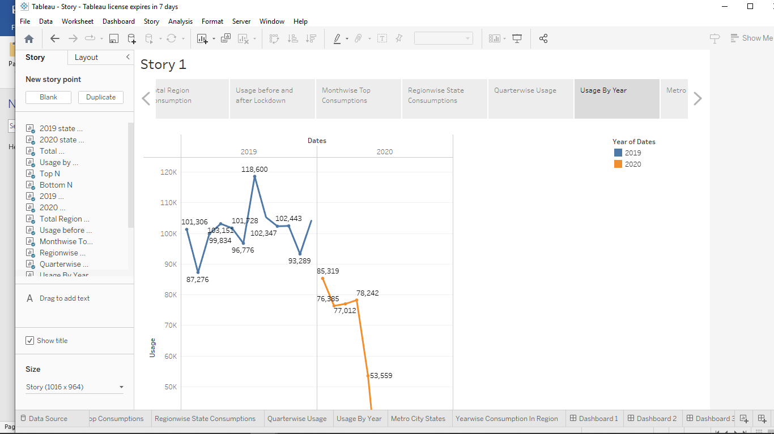

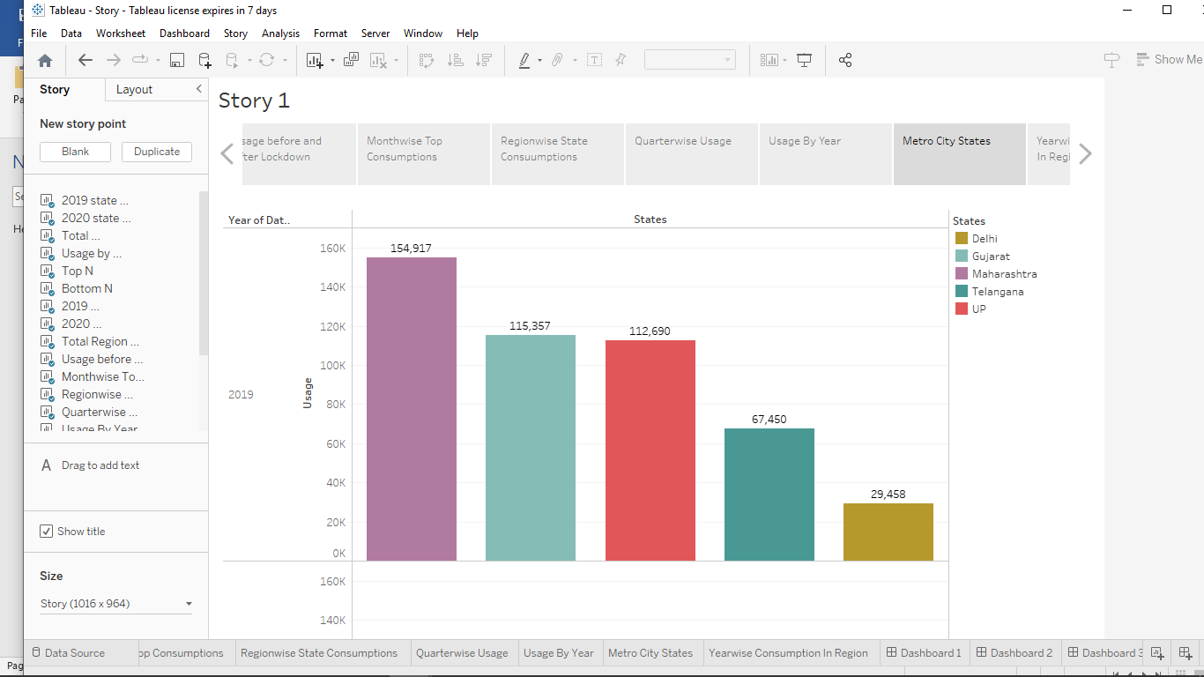

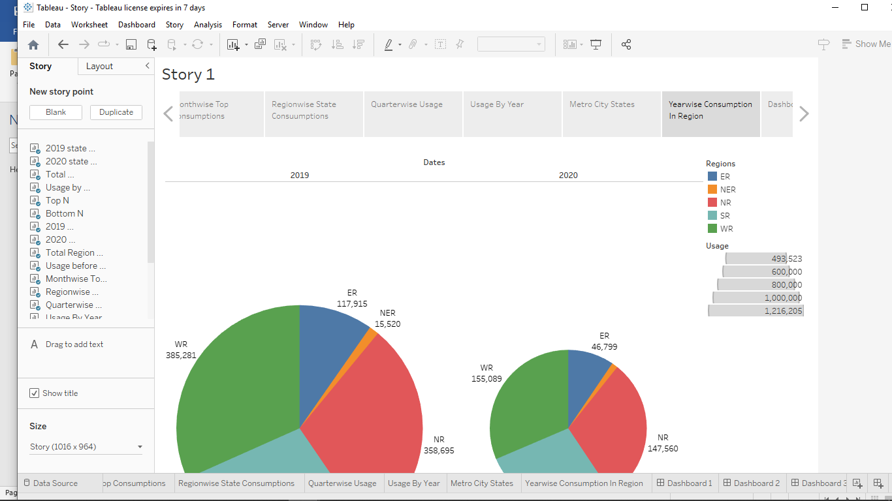

CONCLUSION:

In the Stated Policies Scenario, electricity generation from renewables increases rapidly, surpassing coal by 2026. Renewables contribute three-quarters of electricity supply growth to 2040, underpinned by policy support in nearly 170 countries and falling costs. Coal-fired output remains broadly flat, though its share declines significantly, while natural gas and nuclear power maintain their shares.

In the Sustainable Development Scenario, renewables provide two-thirds of electricity supply worldwide by 2040: solar PV and wind together provide 40%, with a further 25% from dispatchable renewables, including hydro and bioenergy. Nuclear power expands and close to 320 GW of coal and gas-fired capacity is equipped with CCUS. Unabated coal-fired power is almost completely phased out by 2040, addressing the largest single source of CO2 emissions, while gas-fired power remains an important source of flexibility.